

**Olympics 2024 Website Documentation**

**Sitemap English**

Olympic Games

Feedback Form

Specific Sports page

Biography

Gallery

Athletes

Sports

Olympics

Home.html

INTRODUCTION

This document provides a comprehensive overview of the Olympics website developed for an institute presentation. The primary objective of the website is to serve as an informative and engaging platform for users interested in the Olympic Games, showcasing various aspects such as historical data, upcoming events, athlete profiles, and medal tallies. Designed with user experience in mind, the website features a clean and intuitive layout that allows visitors to easily navigate through the content. Key components include a navigation bar for seamless access to different sections, a dynamic carousel that highlights important news and events, and a cards section that presents detailed information about athletes and competitions in an organized manner. In addition to its aesthetic appeal, the website aims to foster user engagement by providing interactive elements and up-to-date information. The carousel serves as a focal point, drawing attention to significant announcements and featured articles, while the cards section allows users to explore specific topics in depth. By integrating these features, the website not only informs users about the Olympics but also encourages them to delve deeper into the rich history and excitement surrounding the Games. Overall, this project reflects a commitment to creating a valuable resource for Olympic enthusiasts and aims to inspire a greater appreciation for this global sporting event.

**TECHNOLOGY USED**

* **HTML** – For structuring the webpage
* **CSS** – For styling and responsive design
* **JavaScript** – For interactive features
* **Bootstrap 5** – For pre-built UI components and responsiveness

Home page

NAVBAR

The **navbar** is placed at the top of the page and contains links to different sections of the website. It is fully responsive and includes:

* A **logo** on the left
* Navigation **menu items** (Olympic Games, Athletes, Sports, Gallery, Contact Us)
* A **hamburger menu** for mobile devices
* Smooth scrolling to different sections

Carousel

The **carousel** is placed below the navbar and is used to showcase high-quality images and videos related to the Olympics. It includes:

* **Autoplay feature** (optional)
* **Navigation controls** (previous/next buttons)
* **Indicators** for slide selection
* **Support for videos and images**

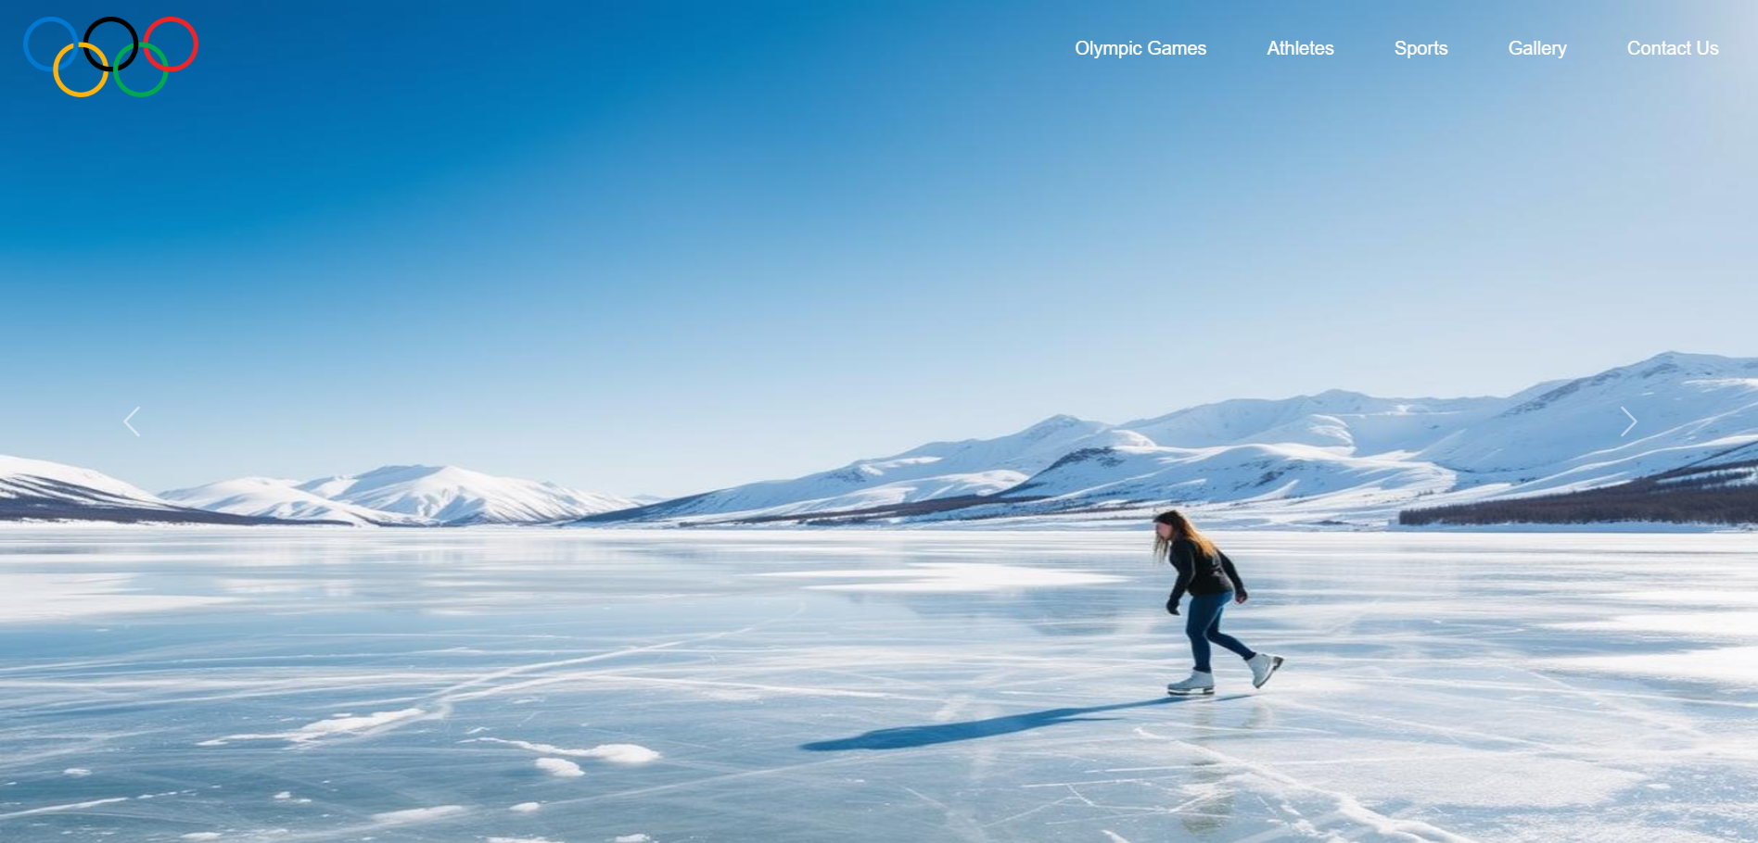

Home page

Cards

* Each **card** includes image thumbnails that function as clickable **anchor tags**, enabling users to easily access additional information.
* **Titles and descriptions** within the cards are also implemented as **anchor tags**, ensuring a seamless navigation experience for users exploring specific topics in greater depth.

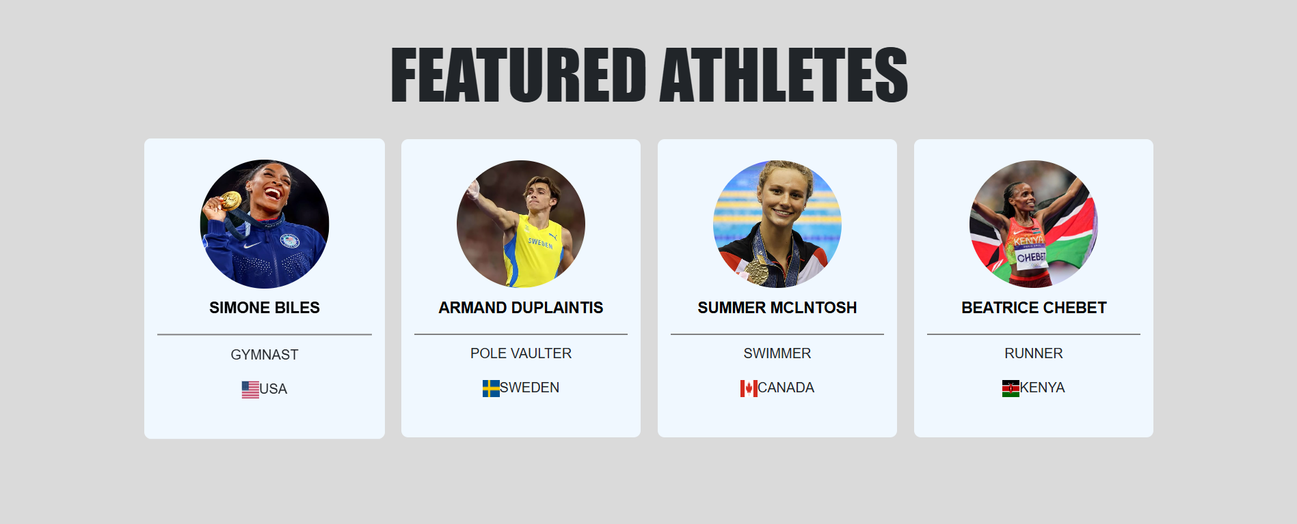

Home page

Video Section with Description

A **video section** has been added to enhance the interactive experience of the website. It includes:

* An embedded **Olympics 2024 video**.
* Below the video, a **text description** provides an overview of the event.
* This section is designed to be fully responsive and engaging for visitors.

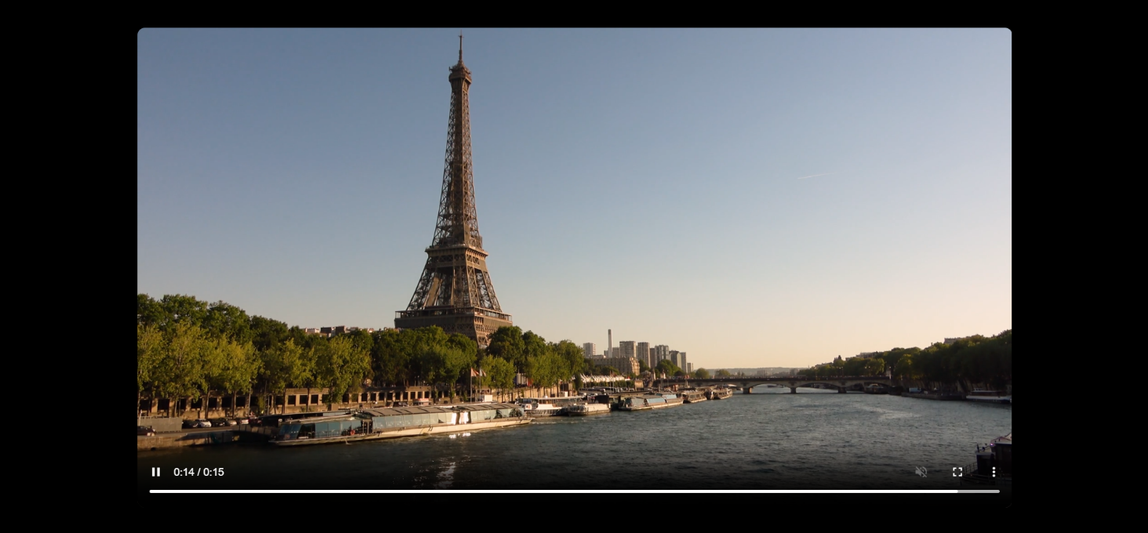

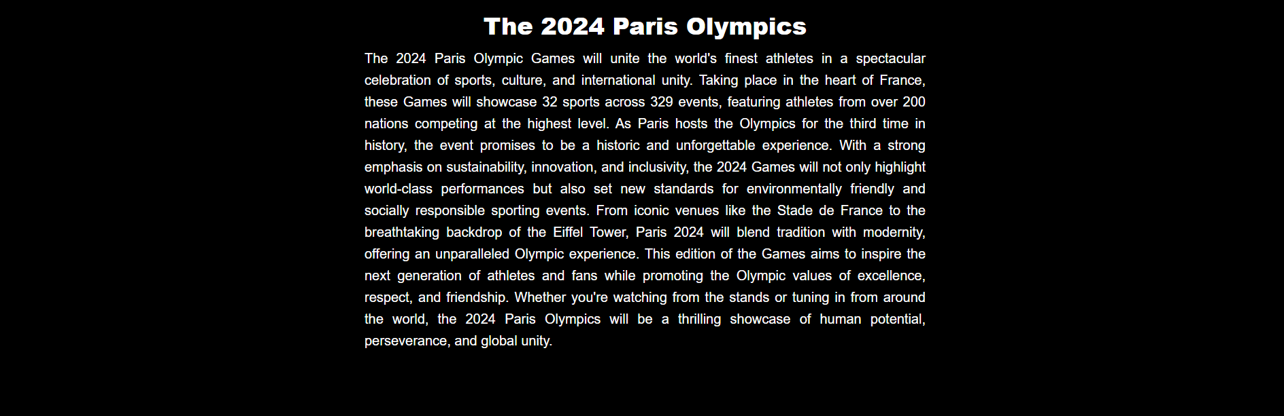

Home page

Next Game Section with Timer

A **Next Game** section has been added to highlight the upcoming Olympics event. It includes:

* A **centered heading** displaying "Next Game".
* A **JavaScript-based countdown timer** showing the time left until the 2026 Olympics.
* An **image** with text overlay that links to the **Olympics 2026 website**.

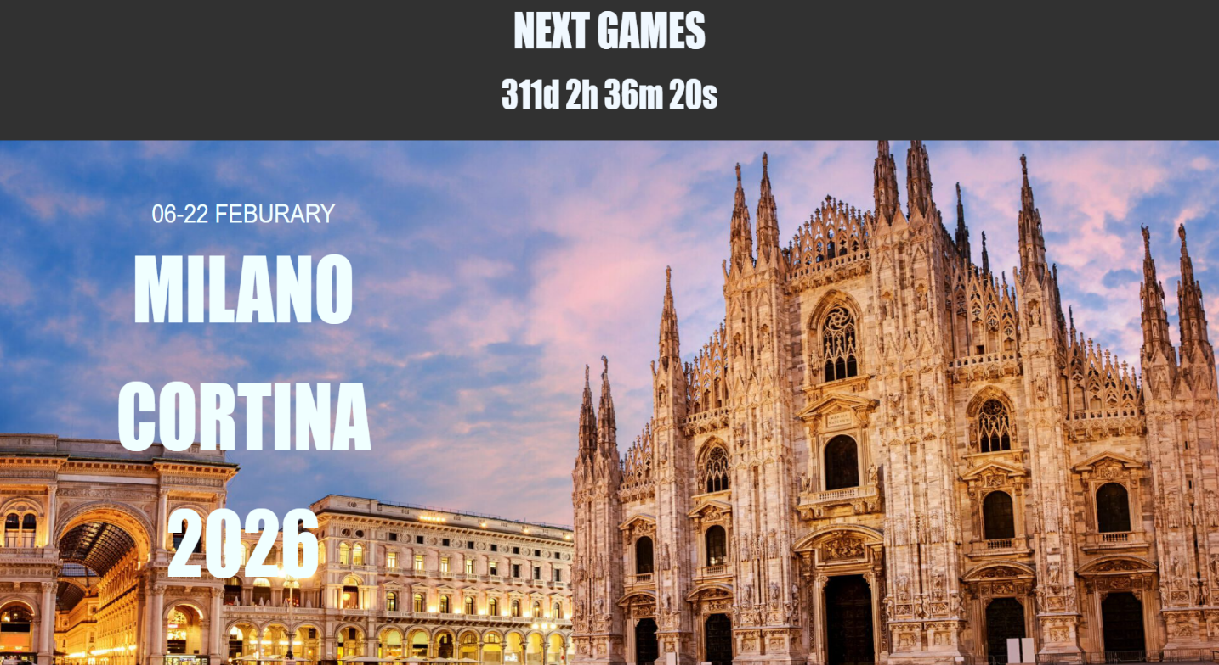

Home page

Expandable Paragraphs Section

This section includes **four paragraphs** where:

* Initially, only **two paragraphs** are visible.
* A **button** is provided to reveal the remaining two paragraphs.
* JavaScript is used to toggle the visibility of the extra paragraphs dynamically.
* Each paragraph has a **hover effect** for better user interaction.

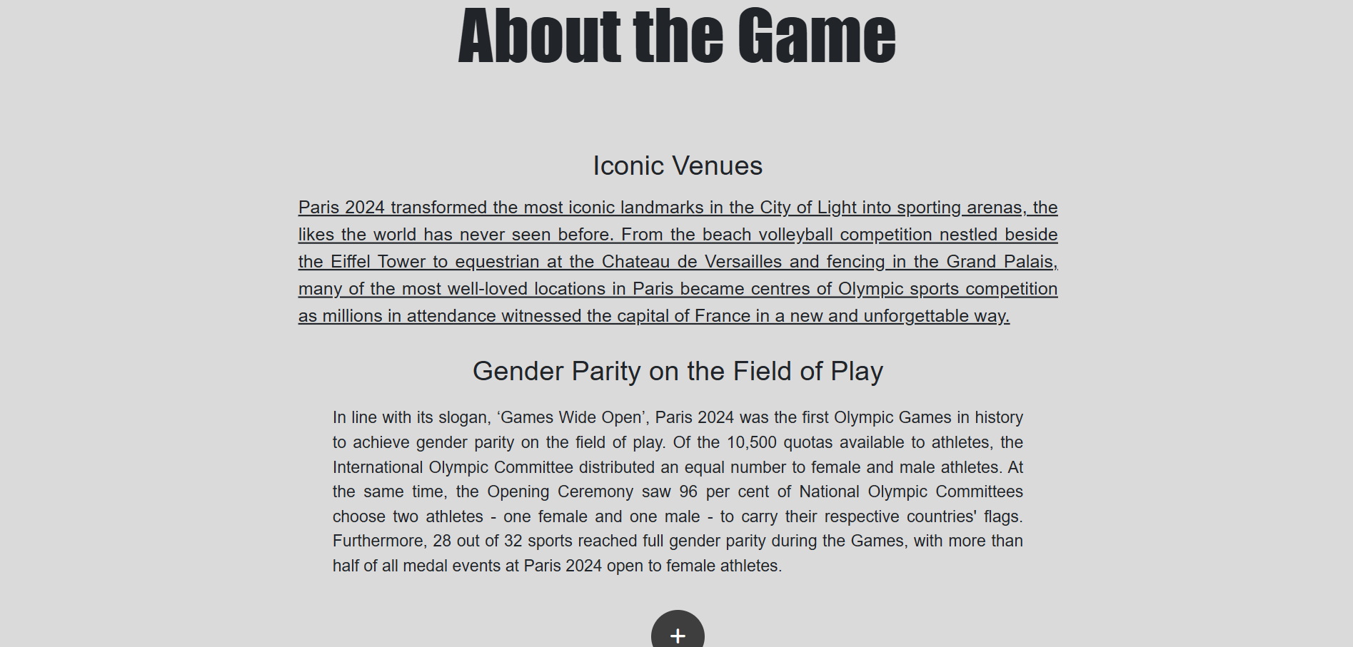

Home page

Olympics Partners Section

This section showcases **official partners and sponsors of the Olympics**. It includes:

* Multiple **brand logos** displayed in separate divs.
* Each logo is linked to the respective **official brand website**.
* A **responsive layout** ensuring proper visibility on all screen sizes.

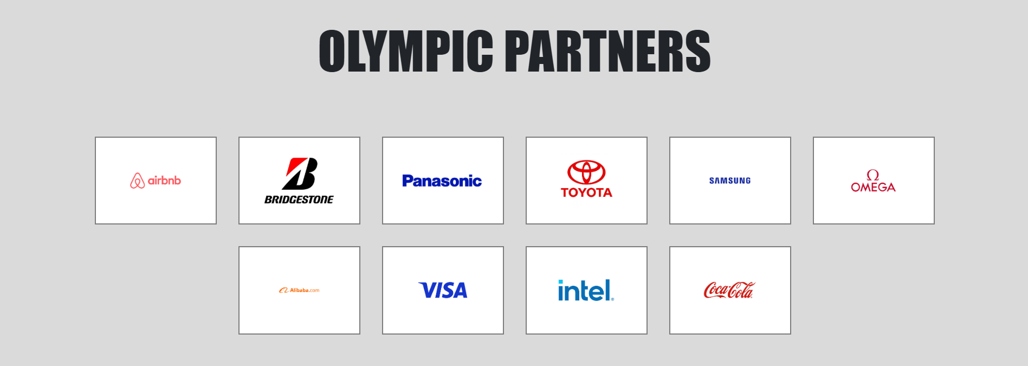

Home page

Footer Section

The **footer** provides essential links and branding elements, including:

* An **Olympics logo** linked to the homepage.
* Additional **information links** (e.g., Terms & Conditions, Privacy Policy, Contact).
* **Social media icons** linked to respective platforms (Facebook, Twitter, Instagram, etc.).
* A **fully responsive design** ensuring proper alignment on all devices.



Olympic games

**Olympic Games Menu**

* + A dedicated menu item labeled "Olympic Games" in the navbar.
  + On hovering over it, a dropdown box appears.
  + The dropdown contains a list of upcoming Olympic events.
  + Each event in the list is linked to its respective official website for more details.

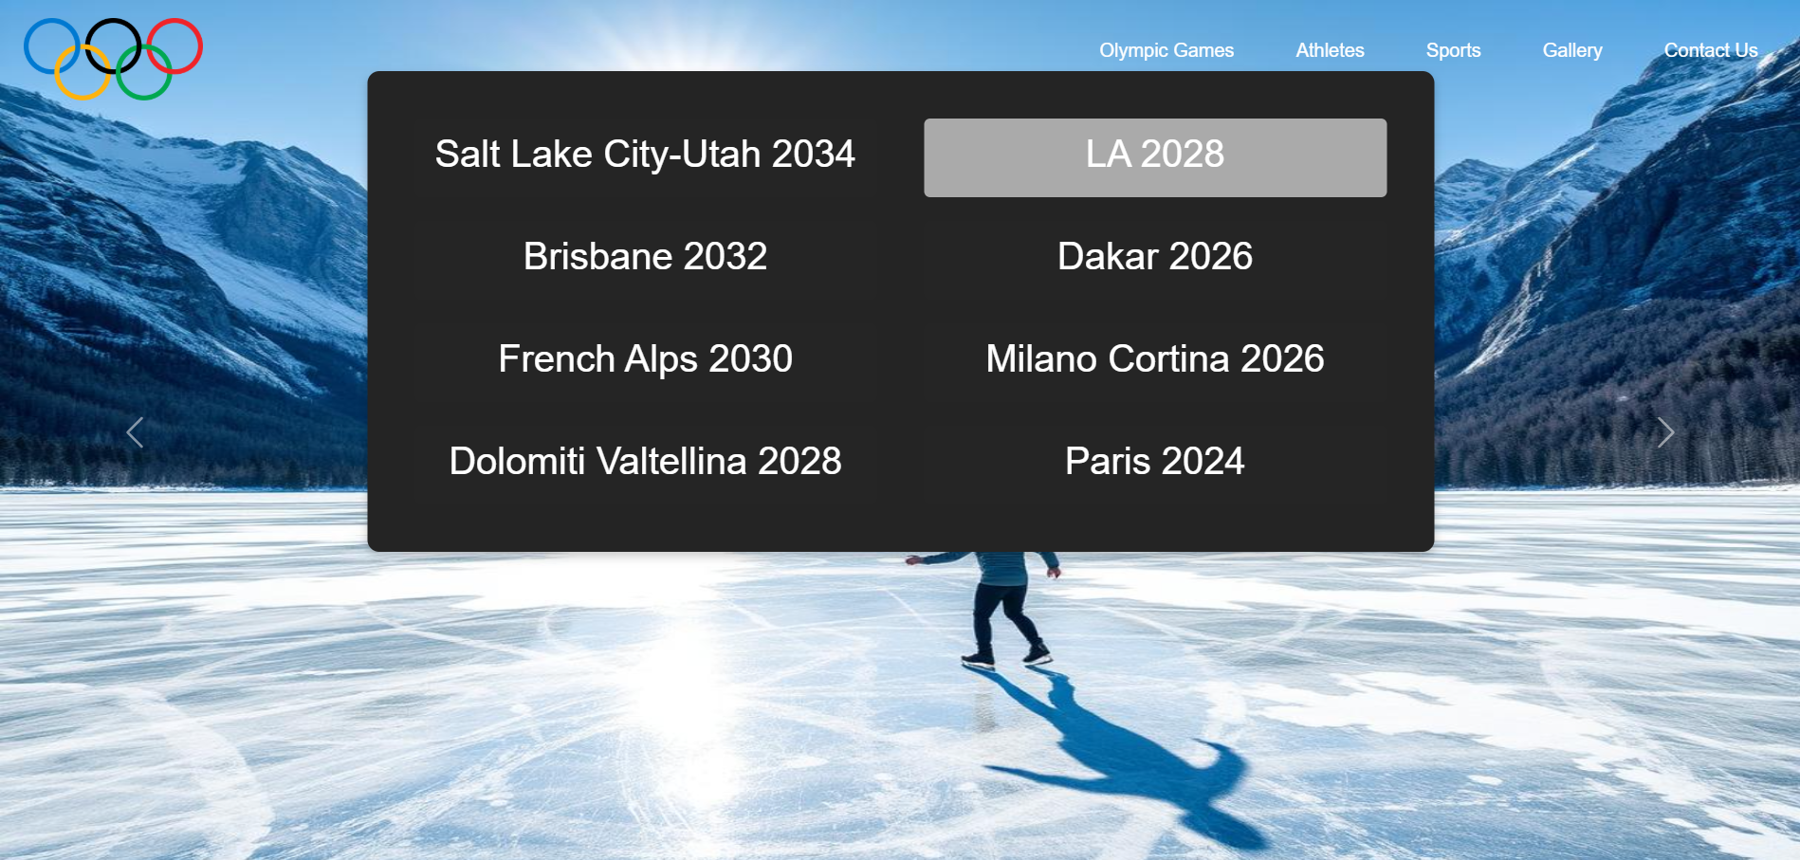

Athletes

**Athlete Cards**

* Each athlete is represented by a card containing their image and name.
* The cards are visually appealing and provide quick access to athlete details.
* When hovered over, the cards transition smoothly to reveal additional information.
* The transition effect improves user engagement and provides a modern look.
* Each card is linked to a detailed biography page of the respective athlete.
* Clicking on a image or name redirects users to the athlete's profile for more information.

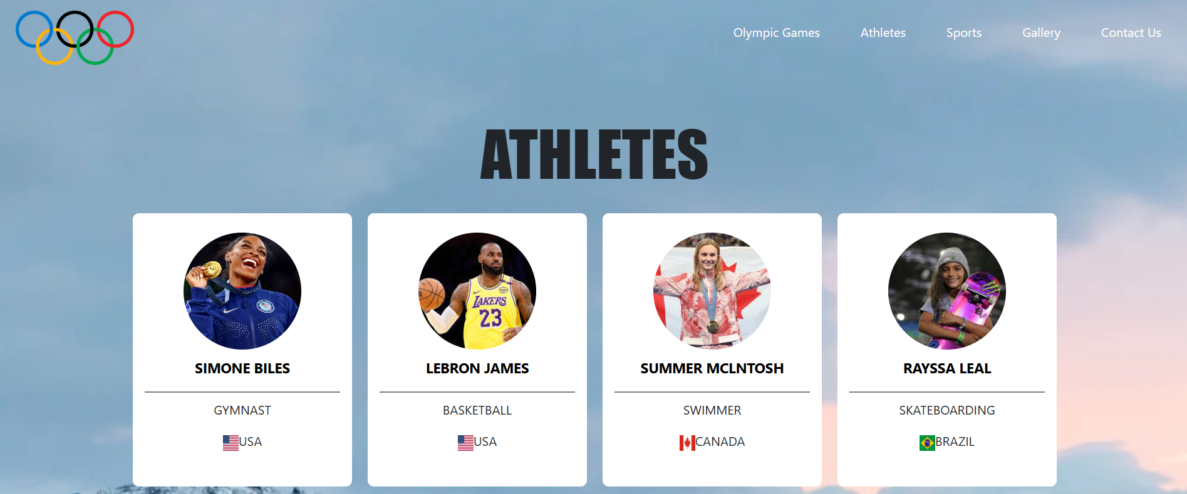

Biography page

Biography

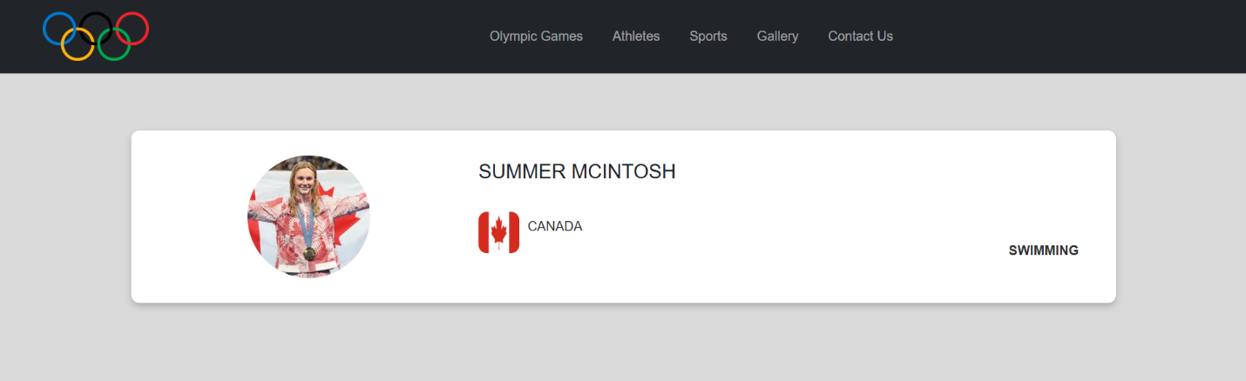

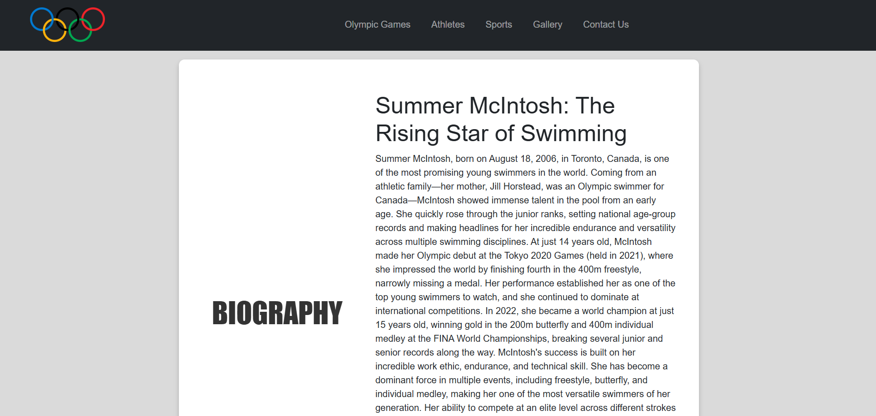

Sports page

**Features of the Sports Page:**

* A visually appealing div is placed at the center of the page for easy access.
* Contains multiple buttons representing different sports such as:
  + Swimming
  + Table Tennis
  + Cycling
  + And more...
* When hovered over, the buttons transition smoothly, enhancing user engagement.
* The transition effects provide a modern and dynamic feel to the page.
* Each button links to a dedicated page for the respective sport.
* Clicking a button redirects users to detailed information about that sport.

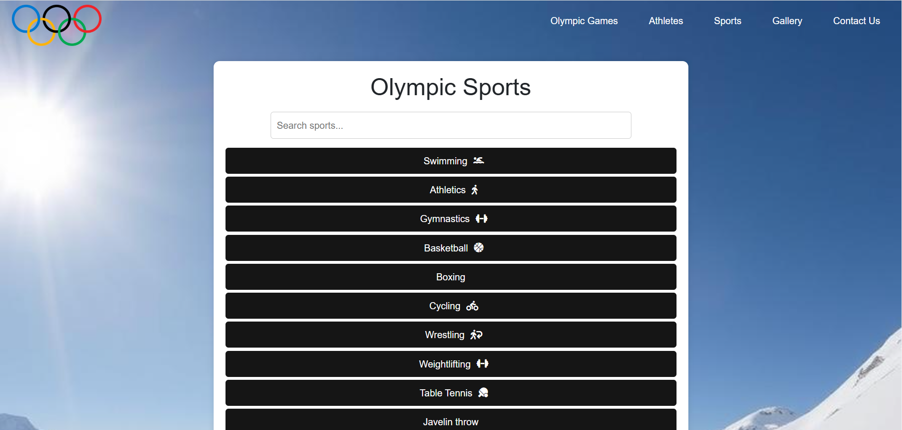

Sport page

Specific sport page

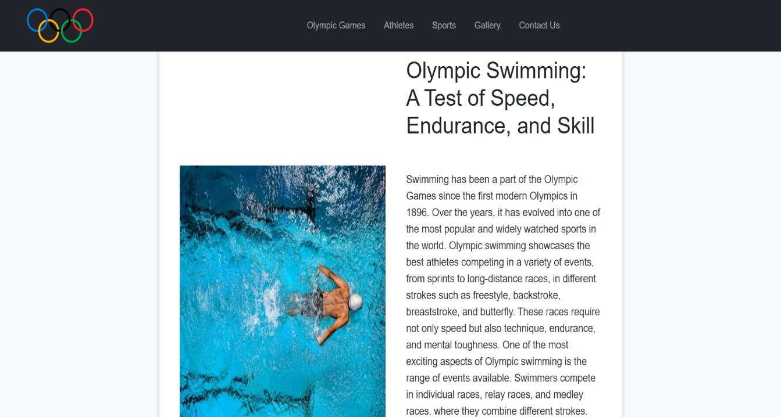

Gallery page

**Features of the Gallery Page**

* + Displays all images used across the website, categorized for easy browsing.
  + Includes images from different sections such as sports, athletes, and events.
  + When hovered over, images smoothly transition with effects such as zoom-in or fade.
  + Enhances user experience by providing a dynamic visual appeal.
  + Clicking on an image enlarges it in a lightbox or modal view for better visibility.

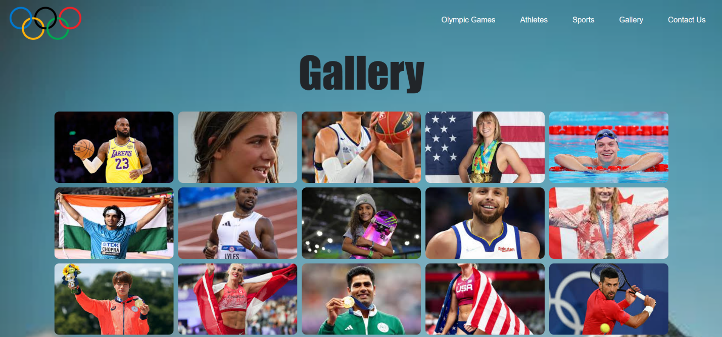

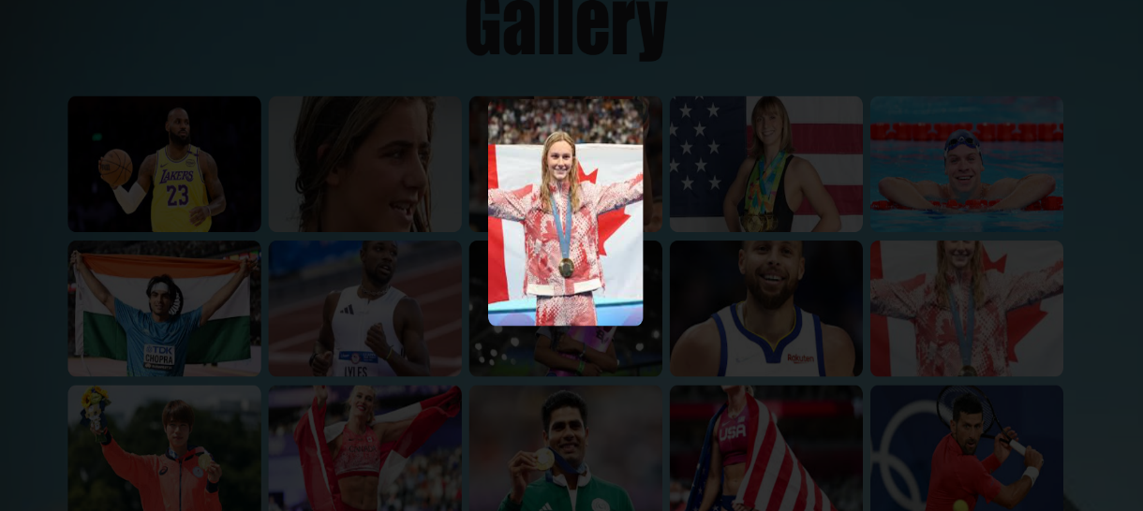

Contact page

Feedback Form

* + Users can enter their name (optional) and email address (optional).
  + A dedicated text field for suggestions and reviews (mandatory).
  + If the suggestion and review field is left empty, a validation message appears.
  + Ensures that users provide valuable feedback before submission.
  + A submit button is included for easy form submission.
  + Error messages appear dynamically to guide users in completing the form.

